ST. FRANCIS XAVIER SCHOOLS
ACADEMIC CALENDAR 2019/20

TERM 1

Re-opening Thursday, 29th August 2019 at 8.50am
In-service Day Wednesday, 25th September
- Senior School Only for New Languages
Curriculum training
Midterm October 28th - November 1st (inclusive)
School reopens Monday, 4th November

Christmas Break
- Closing Friday 20th December 2019
- Reopening Monday, 6th January 2020

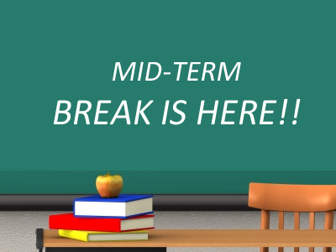 | TERM 2  Midterm Break Thurs 20th & Fri 21st February
St. Patrick’s Day Closure
- Friday 13th, Mon 16th March & Tues 17th March

Easter Break
- School closes Friday 3rd April
- Re-opening Monday, 20th April

TERM 3

May Bank Holiday Monday, 4th May
June Week 1st - 5th June (inclusive)
School reopens Monday 8th June
Summer Holidays Tuesday, 30th June

