Our ATP Team meet An Taoiseach in eBay!
Our ATP Team (Action Team for Partnership) were invited to eBay last week to attend their Expo on Culture & the Community! Our pupils and staff met with An Taoiseach and also Mr Derek Allgood, eBay Vice-President of Global Customer Services. Impressed by their surrounds, eBay has secured a number of future SFX recruits!!!

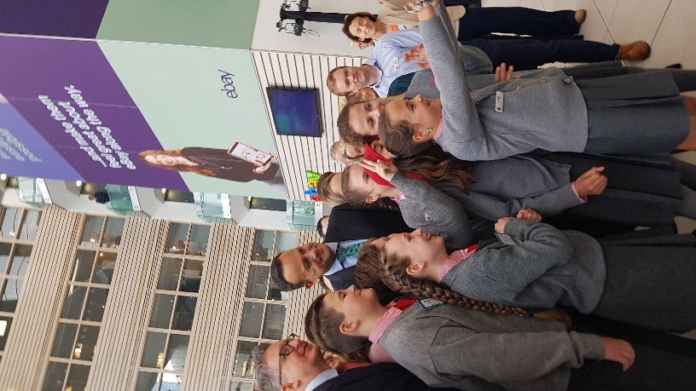 Taking a selfie with An Taoiseach!!!!!!

