St. Francis Xavier Senior School
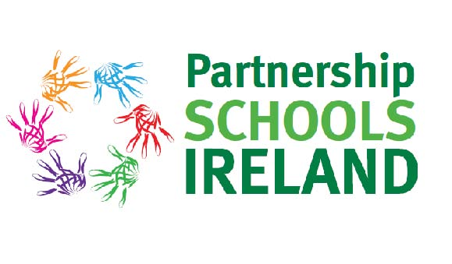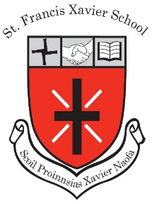
October Newsletter

Here at SFX Senior School we have had a very busy few weeks since our last newsletter!

Mental Health Awareness Week 7th-11th October
Our month started off celebrating Mental Health Week. Over the course of the week we included the five approaches to wellbeing choosing one approach for each day:
- Connect - “Invisible Friend”
- Be Active - 5,000 Steps to Wellbeing
- Take Notice - …of things other children enjoy and which make them happy
- Keep Learning - Developing skills for the promotion of mental wellbeing
- Give - Extend kindness to another person
Our pupils and staff all embraced this important week and engaged in all activities, the most popular of which being the connection activity, namely “Invisible Friend”. Every child and adult in the school had an Invisible Friend and throughout the week they received Invisible Post and also carried our small acts of kindness. Our ATP team (Action Team for Partnership) supported Mental Health Week with the launch of their new initiative the “Gratitude Journal”. All pupils and staff take a moment at the start of the school day to write something they are grateful for - a wonderful way to set up your day!

Maths Week 14th -21th October
Great fun was had by all pupils during Maths Week recently with a great variety of fun activities for all classes. There was a fantastic response to our Maths Eyes Diary and poster competitions and we thank parents for their support with these projects which is always greatly appreciated. Maths posters and diaries will be displayed in the school during the month of November. Be sure to check them out during your visit to the school for our Parent Teacher meetings!

Sports News
- Basketball - Basketball teams took part in the Mini Basketball League recently. They performed very well and are very excited about taking their teams to the National Basketball Arena in Tallaght to represent their school.

- Football - Our Senior Boys’ GAA team made it through to the semi-finals of the Cumann na mBunscol where they bravely fought a close game against Donabate Educate Together NS. Our thanks to our PA who are funding the balance of payment for the Girls’ GAA jerseys. We greatly appreciate your support. We are also grateful to St. Brigid’s GAA Club for providing free coaching for all classes this term with Coach Colm who’s coaching skills and winning personality are ensuring

- Soccer News - 16 boys and girls from 4th class took part in the Respect Cup Soccer Blitz in Corduff recently. Well done to all who took part! All pupils performed really well with the boys’ team making it all the way to the final! Maith sibh!
Congratulations to Grace Crawford, Alex Kovalenko, Anna Chair, Aoife Clarke and Hayley O’Reilly who completed the artwork for the soccer blitz competition and were chosen as the winning entry!!!! The prize was €100 for the winning school which will be put towards additional soccer jerseys for the boys’ team.

- Cross Country - Our cross country teams have taken part in two races this term and our boys and girls did our school proud! There will be two further races in the Spring term.

Action Team for Partnership make the National News!!
Our ATP team hit the headlines in the national and local newspapers this month when they represented our school at a Culture and Community Expo in eBay. Our pupils were delighted with the opportunity to meet with An Taoiseach once again, even capturing a selfie with our famous past pupil! Their photos are in the current edition of the Dublin Gazette and were also in the Irish Independent on Saturday, 12th October. We are delighted with our continued and valuable partnership with eBay through our Action team for Partnership.

Student Council News
Congratulations to the following pupils who were elected by their classmates for Student Council 2019/20:
Keelin Dooley Rm 1
Crean O’Connor Rm 1

Cara Dixon Rm 2
Owen Mitchell Rm 2

Caoimhe Malone Rm 3
Philip Mitten Rm 3

Our Student Council held a very successful Bake Sale yesterday to fund activities during the year including our upcoming Wellbeing Week in November. More news to follow!! Many thanks to all parents and pupils who baked such delicious treats resulting in the sum of €882 being raised!

Parent Teacher Meetings Reminder! - 20th &21st November
We look forward to our annual Parent Teacher Meetings on Wednesday 20th & Thursday 21st November.
Appointments will be scheduled the week we return following midterm break.

Fire Safety Talks
Garda Séan Breheny visited our 5th & 6th classes earlier this week to discuss safety during the Hallowe’en period. Pupils actively engaged in the discussions and learned about the work the Gardaí are involved in during Hallowe’en.

Hallowe’en Costume Day
Today our pupils (and staff!) brought great fun and colour to the school with their fabulous costumes and make up. A fun way to end a successful half-term!

Wishing all our pupils, families and staff an enjoyable and safe midterm break.

Adrienne Darby, Príomhoide & all the staff at SFX Senior School

