St. Francis Xavier Senior School
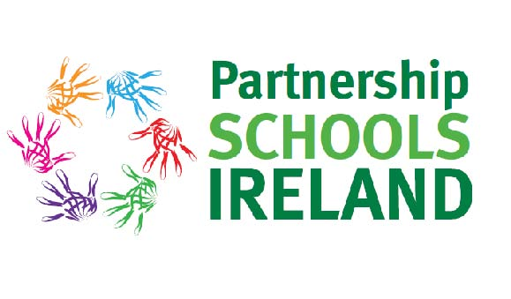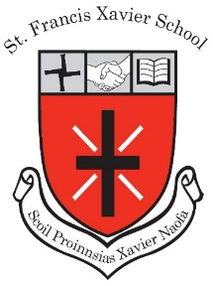
January 2020 Newsletter

Here at SFX Senior School we have had a very busy few weeks since our last newsletter!
January 2020 and it’s all about STEM (Science, Technology, Engineering, Maths!

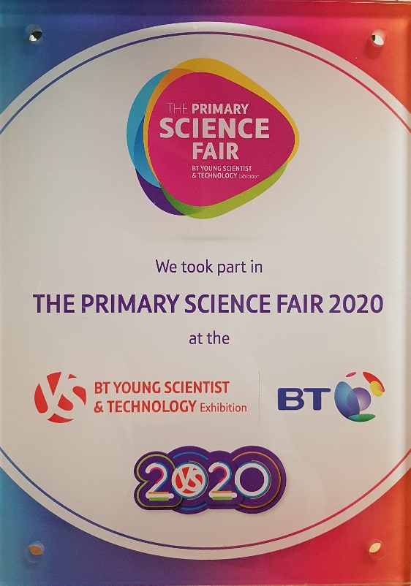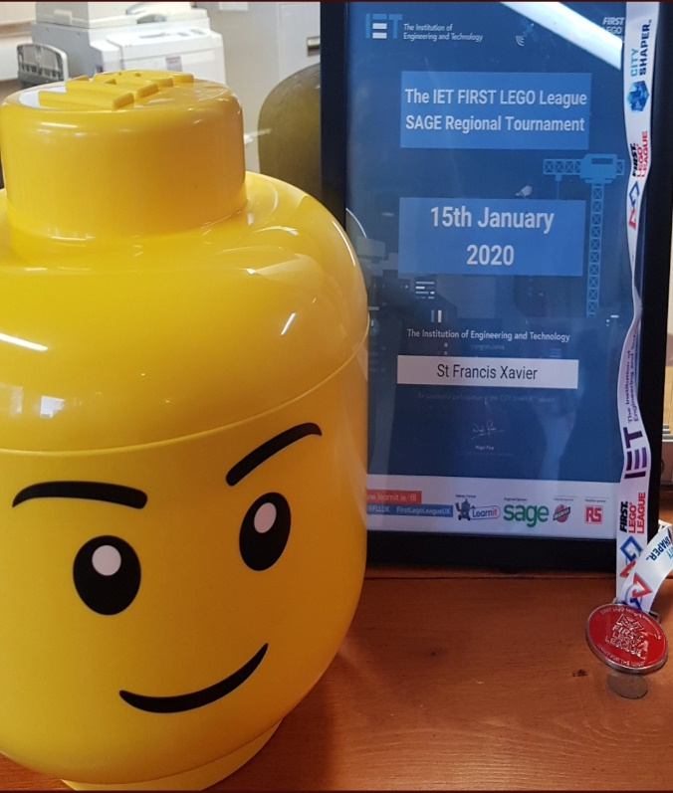

BT Young Scientist Exhibition
Mr. Stokes’ 3rd class were the youngest participants in the BT Young Scientist & Technology Exhibition (#BTYSTE2020) in the RDS presenting a class project on “Why is the Sky Blue?” This young class caught the attention of RTE reporter George Lee and even made it to the RTE News! The participation of the school also made it to social media including IPIC Ireland who tweeted: “Brilliant to see future scientists teaching everyone @BTYSTE “Why the Sky is Blue?” Be sure to visit Mr Stokes’ Class Blog section on our website where you can read more about this project!
Sage First Lego Exhibition
Keeping with the STEM theme, Ms. Walsh’s 6th class entered three projects in the First Lego League at the SAGE Science & Technology competition held in Dublin last week. The organising body - Learnit, are delivery partners of IET(Institute of Engineering and Technology) while SAGE were one of the key sponsors of this event. The pupils’ projects involved identifying problems in the community and using innovative ideas to find a solution to this problems using core values such as Teamwork, Discovery, Innovation, Inclusion, Impact & Fun. Key skills for their project included identifying the problem, looking at possible solutions, looking at constraints, presenting research findings, using sources, working through the design process and presenting their design. Well done to all pupils in Room 1 and to their teacher Ms Walsh on getting recognition for excellent project work! Our thanks also to one of our parents, Simon Bell of SAGE, for visiting the class and providing guidance for this project.
Survey on Wellbeing Week 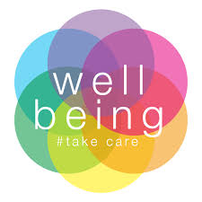
Many thanks to all parents who completed the Wellbeing survey sent home this month. Your feedback is important to us and will help inform future wellbeing initiatives. The Action Team for Partnership (ATP) are currently collating the survey data and will communicate our findings to parents next month.

Debating Competition
Congratulations to our Debating Team who are now through to the semi-finals of the Concern Dublin Primary Schools’ Debating Competition having defeated Carysfort N.S., Blackrock. The motion “World Hunger will be eliminated by 2030” was a particularly challenging topic to propose but our team of researchers and debaters did extraordinary work over the past two weeks resulting in their win.
Internet Safety Week 10th - 14th February 2020
Internet Safety Week takes place in our school from 10th - 14th February. This is a very important annual event in our school where the pupils are engaged in a schedule of activities including WebWise Lessons and art competitions. In the preceding week, Paula O’Connor, an expert in all cyber safety related matters will deliver workshops to both pupils and parents. Our thanks to Ms Greene for co-ordinating these events.

“Keeping Your Child Safe Online”
Parent Information Morning
Wed, 5th February at 9am
SFX Senior School Hall

