How To Access Your Class GDrive where your teacher will upload all your class work.
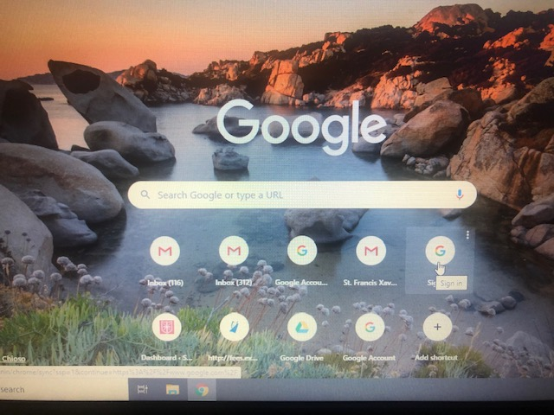

- Open Google and click Sign in

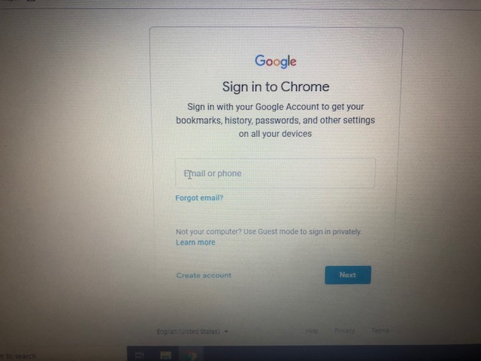
- Type in the email address sent by text for your class --------@sfxns.ie
Then click next.

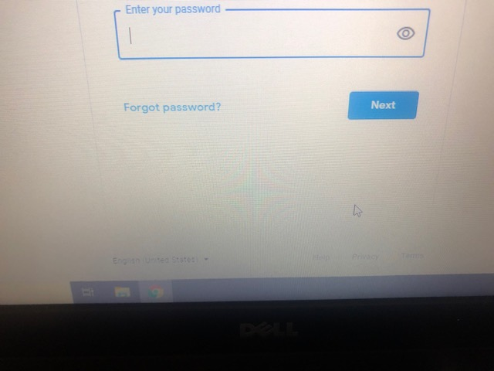

- Type in password for your class sent by text and press next.

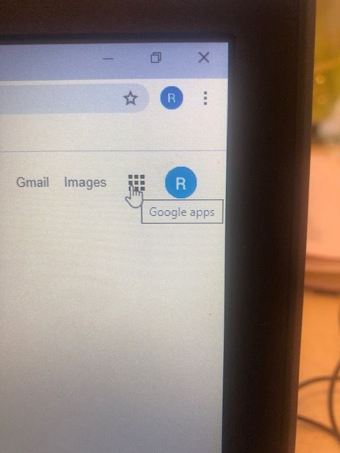
- Go to right of screen where there are 9 dots click dots

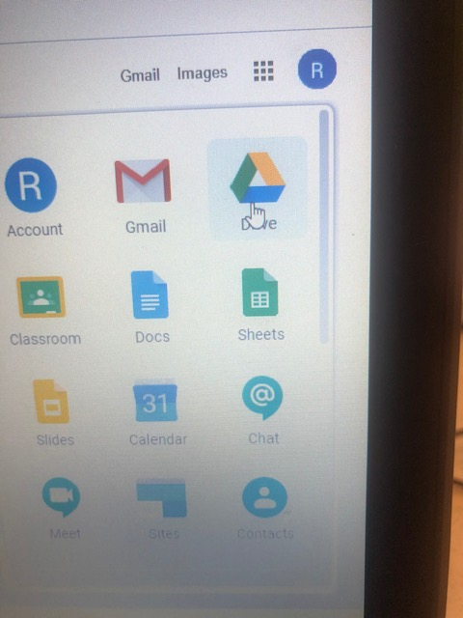
- Click on Drive and documents with your work can be seen.
- Do not upload documents or email this drive just check your list of work for each day.
- Each maths group teacher will upload your work to your main class drive.

