St. Francis Xavier Senior School
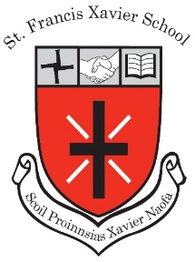

SFX Weekly Newsletter (No. 6, 8th May 2020)
“Supporting you in supporting your child’s learning.
Whatever works for your family, Works for us.”
Dear Parents,
Enhancing the Home-School Communication Link
We have received an excellent response from parents with their preferred email contact for home-school communication. For any families who have yet to send us their email address, please forward to Louise on o.fficesenior@sfxns.ie

Government Guidance on Return to School
As you will be aware, the Irish Government announced a roadmap for reopening society and business last Friday. Based on this plan, pupils are not scheduled to return to school buildings until September 2020 at the earliest. This will be a disappointment to our pupils not being able to see their classmates and teachers before the end of the academic year. It is especially disappointing for our 6th class pupils and teachers. The final term of primary school is always such a special and memorable time for children before they embark on the next phase of their formal education. Cognisant of this, we wish to reassure parents of the following:

- School management are in communication with our Parents’ Association as we plan for a Graduation event for our 6th class boys and girls.
- We are liaising with the secondary schools these children are due to attend in September in order to facilitate a smooth transition.
- Our school staff are in regular discussion around ongoing support for all of our pupils and we are working on some fun, novel ways to continue to engage our pupils over the coming months.

End of Year Reports
End-of-Year School Reports will issue as usual this year. While the DES have stated that there will be no standardised testing for this academic year, your child’s report will be based on a range of evidence including learning tasks and class engagement.
Adrienne Darby, Príomhoide - SFX Senior School.
Class Teacher enquiries: g.classroom@sfxns.ie Office Enquiries: o.fficesenior@sfxns.ie

