How to Activate Your Google Account
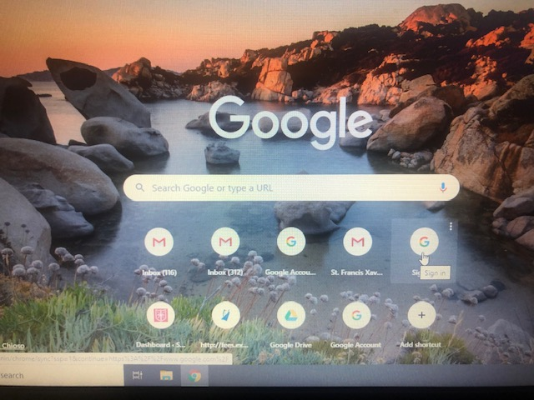

- Open Google and click Sign in

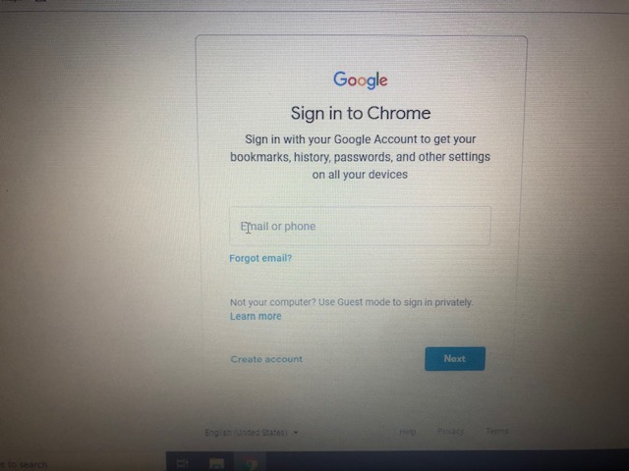
- Type in Your email address --------@sfxns.ie
Then click next.

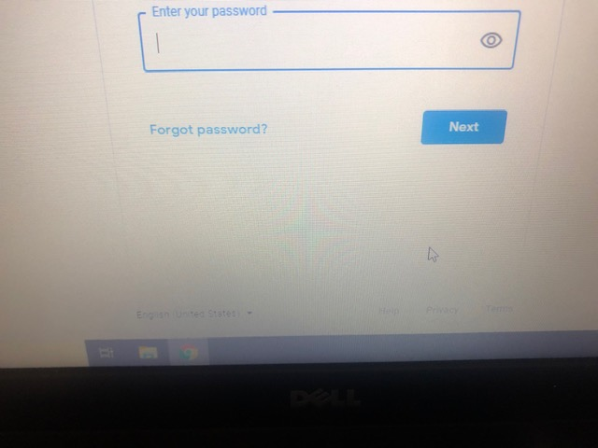

- Type in password: sfxsetup
Click next

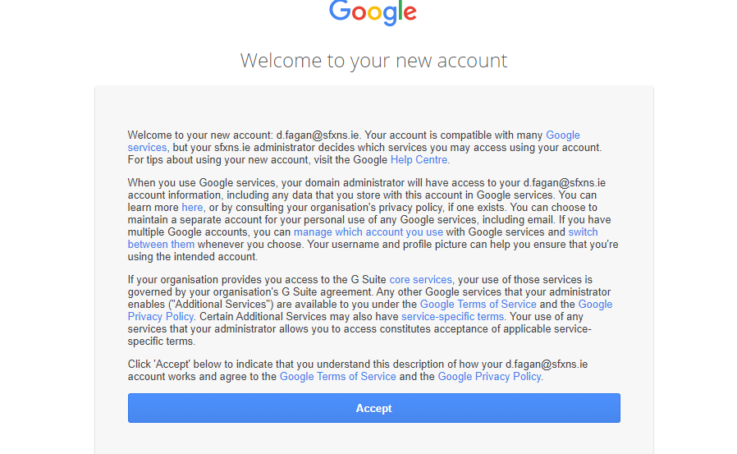
- Welcome to account click accept

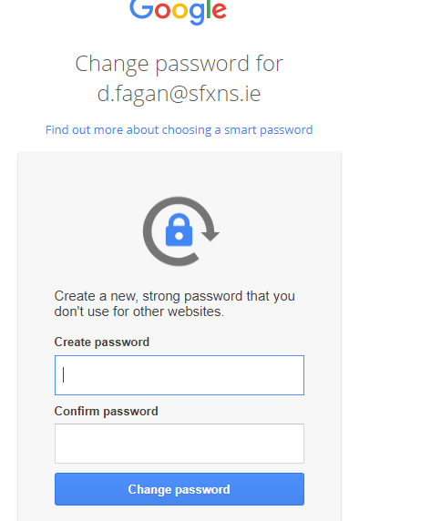
- You will be asked to create your own personal password
Create password, confirm password, click change password

Make sure to record this password so you don’t forget it

- You have now activated your account.

Well Done!!!!!!!

