How To Join Your Google Classroom
Each class teacher is setting up a Google Classroom where they set some work for their pupils. The pupils can complete the work and then submit it back to the teacher for feedback and correction.
Please follow the instructions below to join your class.
Before you begin have the following information with you.
- Your personal ………@sfxns.ie details
- Your password
- The class code from your teacher. This is the same for everyone in your class.

Firstly sign into your account using your ……………….@sfxns.ie email and password.

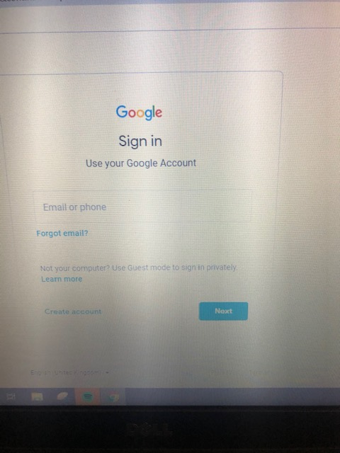

Type in your email then press next.

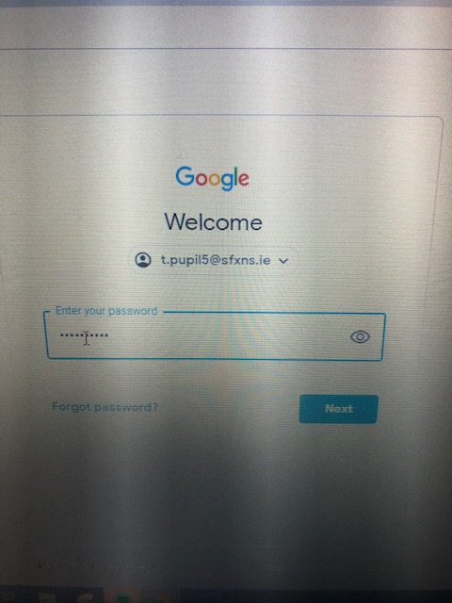
Type in your password then press next

Go to top right of your screen where there are 9 dots.
Click the dots.

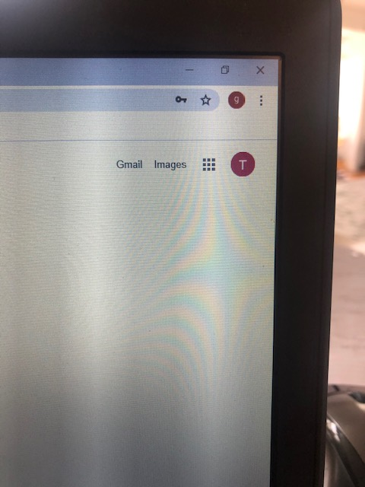

These apps can be seen. Click the one that says Google Classroom.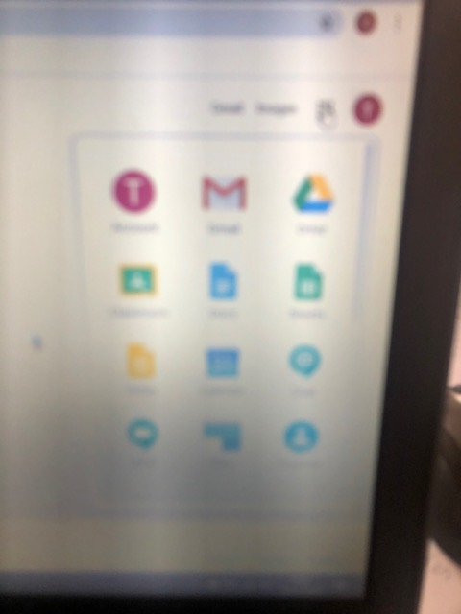

This will appear on your screen. Click continue.
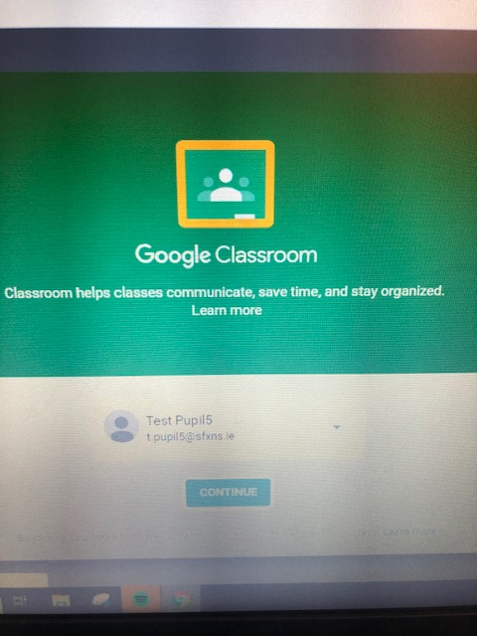

This screen will appear: Click Student Role.
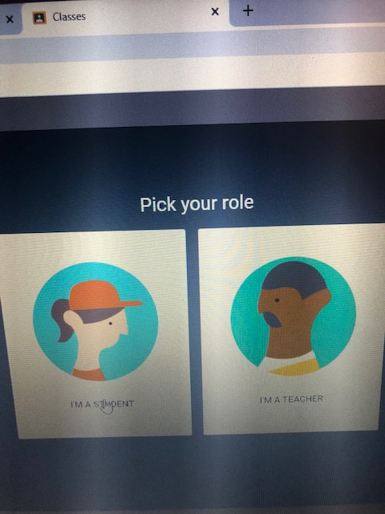

Go to top right of screen + click to join class.
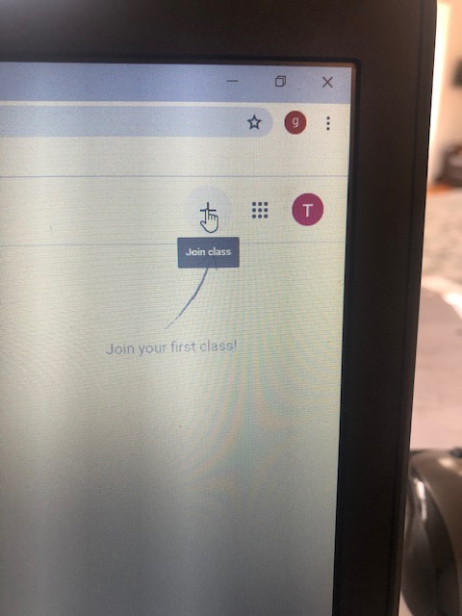

This screen will appear asking you for the code given by your teacher. Type it in and click join.
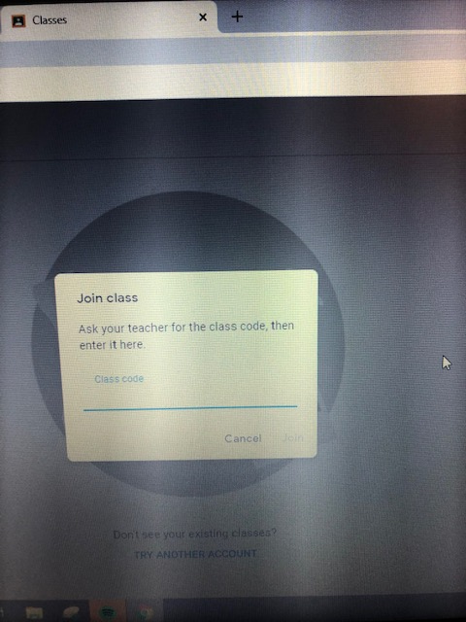

Well done you have now joined your class.

