ST. FRANCIS XAVIER SCHOOLS
ACADEMIC CALENDAR 2020/21

TERM 1

Re-opening Thursday, 27th August

Midterm 26th - 30th October (inclusive)

Christmas Break
- Closing Tuesday 22nd December at 12 noon
- Reopening Wednesday, 6th January 2021

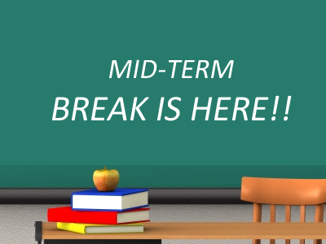 | TERM 2  Midterm Break Monday, 15th - Friday, 19th February  (inclusive)
 | St. Patrick’s Day Wednesday, 17th March
Easter Break
- School closes Friday 26th March at 12 noon
- Reopening Monday, 12th April

TERM 3

May Bank Holiday Monday, 3rd May

June Week 7th - 11th June (inclusive)
Summer Holidays Wed, 30th June at 12noon

