St. Francis Xavier Senior National School

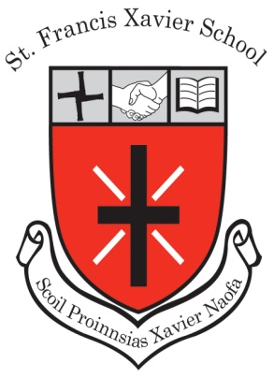
School Evaluation Report & School Improvement Plan

1. Introduction

  - The focus of the evaluation
As part of our ongoing work in the school, a school self-evaluation of teaching and learning in St. Francis Xavier Senior School is undertaken each year. The following curricular areas were identified as key target areas:
- New Primary Languages Curriculum
- SESE - ongoing
- ICT - ongoing
- Wellbeing - ongoing
This school improvement plan sets out our targets for 2019/20.

2. The following areas of development were identified as priorities:

Areas for Development
New Primary Languages Curriculum

- Continue to support teachers in implementing the new Primary Languages Curriculum through engaging sustained support from a PDST Advisor through 2019-20.
- Introduce a whole school plan for teaching comprehension strategies.
- Familiarise all classes with the use of the Creative Writer App on the iPads.

Gaeilge
Promotion of Gaeilge Labhartha through:
- “An Caife Gaeilge”
- Gaeilge Labhartha i rith an lae within the classroom and beyond
- Gaeilgeoir na Míosa award for each class at the monthly assembly
- Achieving targets as set out by “An Gaelbhratach”:
ICT
- Continue to implement the 5 year Digital Framework for the school.
- Introduce chromebooks
- Embed the use of technology in teaching and learning.
Wellbeing
- Refocus the Code of Behaviour to a value driven code
- Empathy Workshops “In Their Shoes”
- SARI Sports Against Racism Ireland Workshops
To support these targets, the following initiatives are being implemented:

- Participation in Action Team Partnership (Partnership Schools Ireland)
- Investment by the Board of Management in Chromebooks
- An Gaelbhratach - the Purple Flag for St Francis Xavier SNS.

